8.32: (a) Momentum conservation tells us that both cars have the same change in momentum, but the smaller car has a greater velocity change because it has a smaller mass.

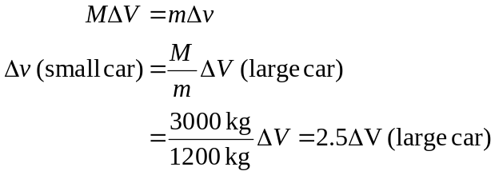
(b) The occupants of the small car experience 2.5 times the velocity change of those in the large car, so they also experience 2.5 times the acceleration. Therefore they feel 2.5 times the force, which causes whiplash and other serious injuries.

